# Reading Challenge Week 3

This reading challenge is worth **20%** of your grade. It will assess your ability to read texts about programming and websites by applying the following strategies:

1. **Vocabulary**
2. **Skimming**
3. **Scanning**
4. **Reference Words**
5. **Main Ideas**
6. **General Reading Comprehension**

# Good luck!

Why Do You Need to Redesign Your Website Constantly?

Is your website feeling stale? It might be time for a redesign. Changing the feel and the user experience on your website can have huge benefits.

## 1.

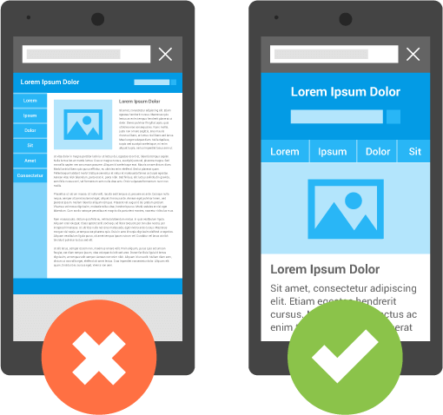

Google recently changed the way sites rank on search engines. **It** added mobile optimization as a requirement for the top position. If you haven’t already optimized your site for mobile devices, now is the time. Mobile screens are constantly changing size, and different devices show off your content in a different way. Responsive Web Design allows the size of the screen to shift based on which device views the site.

Redesigning your website on a regular basis will ensure that you have the

**latest** dimensions available to your customers. Try a free tool

like Google’s Mobile-Friendly Test to see how your page looks on a variety of mobile devices.

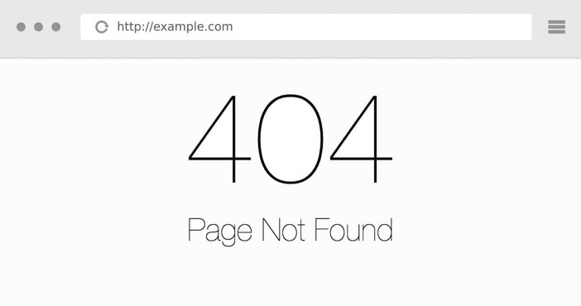

**2. Broken Links**

Source: algorithmia.com

Broken links are a source of frustration to your readers. When a website in your post changes or moves to a different site, the link displayed leads your readers to a dead end. Instead of showing the content that you planned, the link redirects readers to an error page or the wrong website. The only way to check **this** is by performing a manual audit of your links. Change any links that are dead or find a new source.

## 3.



Source: Google Images

Content comes in two categories: time sensitive and evergreen. Time-sensitive content is relevant for when you write it, but **it** expires, changes, or becomes irrelevant. A website full of irrelevant content does not demonstrate a reputable source.

Your readers will assume you don’t know what you are talking about and will look for websites with the most up-to-date information.

Evergreen content provides value to your readers any time they read. The information stays relevant forever and does not expire. Time- sensitive posts mixed with a solid base of evergreen posts give your readers a reason to stick around and explore your site, improving your bounce rate.

## 4.

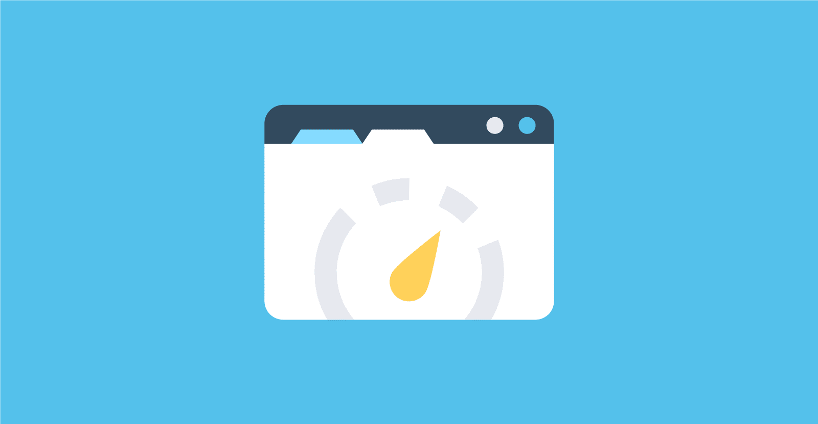

Source: woorkup.com

As your content grows, your website performance can diminish. Google just released a speed update. **It** moves the slowest websites to the bottom of the search results. A good example of this is Flash.

Websites that still use Flash provide a much slower user experience and can create problems for certain devices. In such a case, replacing Flash code with a more current style of code will provide your user with a smoother visit. 3 seconds of waiting will cause half of the US population to leave your site. In a world where speed is everything, you have a very few opportunities to catch a user’s attention.

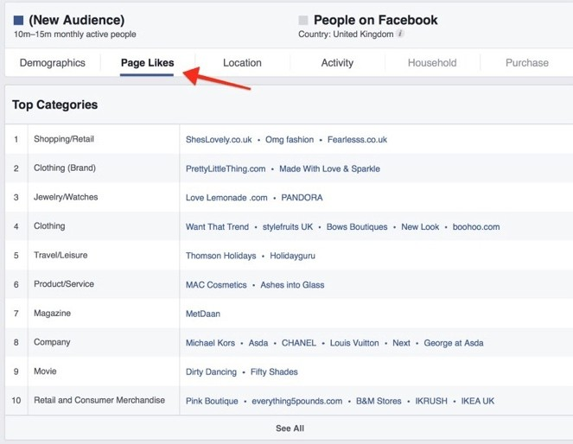

**5.**

Source: Crazyegg.com

Connecting with customers to ask for their feedback will not only improve your website but also improves your relationship. Start by asking them for opinions about your plans for the redesign. Listen to their comments and use them to revise your design. Major retailers such as Amazon and Apple rarely make a complete facelift of their site. Instead, **they** add small **features** requested by their audience in order to improve the user experience.

You can also use heat-mapping tools to see where your audience is clicking on your site. Tools such as CrazyEgg and MockingFish monitor and analyze your site visitors’ clicking and scrolling habits. To know your customers is to serve them better, and they will appreciate you taking the time to get to know their goals and preferences.

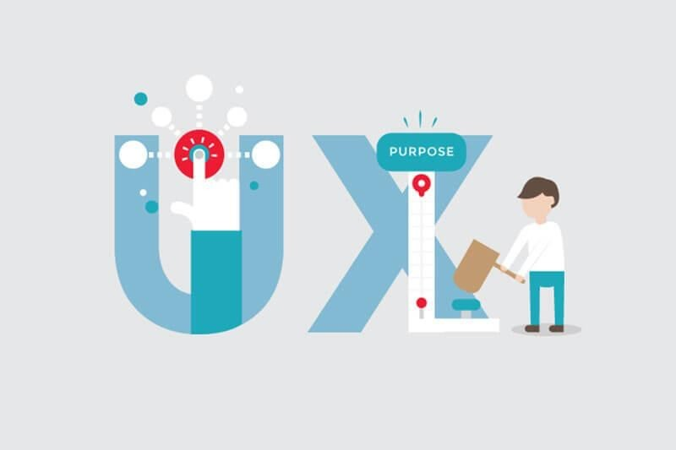

**6.**

Customers like to be in control of their own experience. To achieve this, include visible tools helps viewers to feel confident in their experience. There is a reason why buttons on forms stay translucent until the user completes all the fields. If you find that your users are having a tough time with parts of your site, change it. To make things more forgiving, you can add an undo/redo option, or a back button. This safety net will help users navigate with ease and improve their confidence.

Visual cues such as loading graphics, progress reports, visual workflow, and immediate feedback will tell visitors to keep going. Providing immediate feedback when users complete action **points** them in the right direction and encourages them to continue down the path. Don’t assume that everyone using your website is already an expert. Tutorials and instructions for beginners allow users to navigate your site with ease.